|  |  |
| --- | --- |
| Economics 211 | Macroeconomic Principles |
| Exam #1 Time: 1h 15m | Date: **9 July 2013** |
| Name ___________________________________ | **Instructor: Brian B. Young** |
| The value of this exam is 100 points. | Please show your work where appropriate! |

**Multiple Choice**

2 points each

1) One reason the demand for Coke might increase is a

A) decrease in price of Coke.

B) decrease in price of Pepsi.

C) very successful advertising campaign for Coke.

D) people begin finding cockroaches in cans of Coke.

2) Consider the market for bread. If the price of wheat rises, then the

A) equilibrium quantity of bread increases.

B) price of bread falls.

C) demand curve for bread shifts leftward.

D) demand curve for bread shifts rightward.

E) supply curve of bread shifts leftward.

3) When supply increases, there is a

A) movement down along the supply curve.

B) rightward shift of the entire supply curve.

C) leftward shift of the entire supply curve.

D) movement up along the supply curve.

4) The law of supply states that, other things remaining the same, if the price of a good falls, then the

A) supply increases.

B) supply decreases.

C) quantity supplied decreases.

D) quantity supplied increases.

5) The demand curve illustrates the law of demand because when the price decreases, the

A) demand increases.

B) demand decreases.

C) quantity demanded decreases.

D) quantity demanded increases.

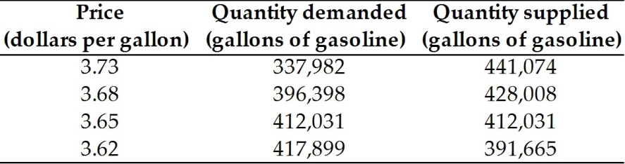

6) The table above shows the situation in the gasoline market in Tulsa, Oklahoma. If the price of a gallon of gasoline is $3.68, then

1. there is a shortage of gasoline in Tulsa.
2. there is a surplus of gasoline in Tulsa.
3. the market for gasoline in Tulsa is in equilibrium.
4. there is neither a shortage nor a surplus, but the market for gasoline is NOT in equilibrium in Tulsa.

7) Gasoline and propane are complements in production. If the price of gasoline rises, then

A) the supply of gasoline will increase.

B) the supply for propane will decrease.

C) the quantity supplied of gasoline will decrease.

D) the supply for propane will increase.

8) A price ceiling set above the equilibrium price leads to

A) a shortage.

B) a surplus.

C) an increase in the quantity bought and sold.

D) no change in either the equilibrium price or the equilibrium quantity

9) A price floor set above the equilibrium price results in

A) a shortage.

B) a surplus.

C) an increase in the quantity bought and sold.

D) no change in either the equilibrium price or the equilibrium quantity.

10) During a recession, when unemployment increases, a country is likely to produce a combination of goods and services illustrated by a point

A) inside its production possibilities frontier.

B) on its production possibilities frontier.

C) outside its production possibilities frontier.

D) either inside or outside but definitely not on its production possibilities frontier.

11) In the real world, opportunity costs

A) increase because resources are not all equally productive at all activities.

B) are constant because resources are not all equally productive at all activities.

C) decrease because resources are not all equally productive at all activities.

D) are sometimes decreasing and sometimes increasing.

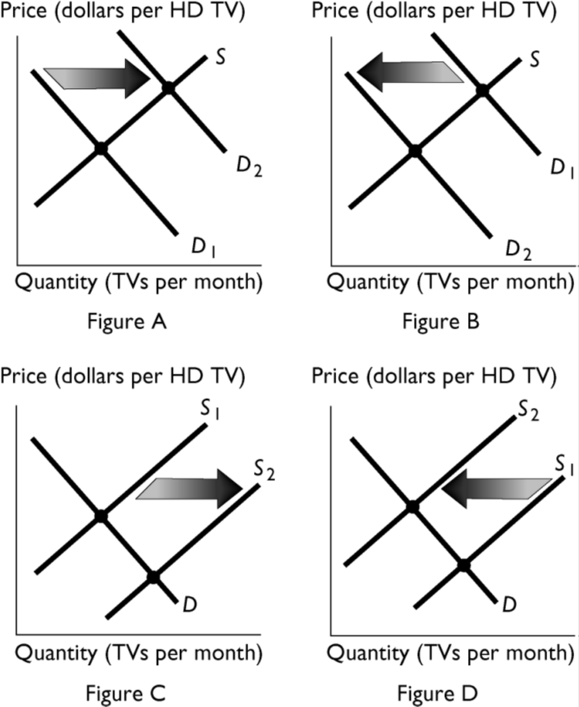

12) The above figures show the market for HD televisions. If people's incomes increase and HD

Televisions are a normal good, which figure shows the effect of this change?

A) Figure A

B) Figure B

C) Figure C

D) Figure D

13) In the absence of external intervention, when the quantity supplied is less than the quantity demanded, there is a

A) shortage and the price will fall.

B) shortage and the price will rise.

C) surplus and the price will rise.

D) surplus and the price will fall.



14) In the above figure, Jack's opportunity cost of producing 1 gallon of soda is ________ of bottled

water.

A) 1/2 of a gallon

B) 1 gallon

C) 6 gallons

D) 2 gallons

E) 1/4 of a gallon

15) In the above figure, Jack's opportunity cost of producing 1 gallon of bottled water is ________ of

soda.

A) 6 gallons

B) 1 gallon

C) 1/2 of a gallon

D) 2 gallons

E) 1/4 of a gallon

16) In the above figure, Jill's opportunity cost of producing 1 gallon of soda is ________ of bottled

water.

A) 1 gallon

B) 1/4 of a gallon

C) 2 gallons

D) 4 gallons

E) 1/2 of a gallon

17) In the above figure, Jill's opportunity cost of producing 1 gallon of bottled water is ________ of

soda.

A) 4 gallons

B) 1 gallon

C) 1/4 of a gallon

D) 1/2 of a gallon

E) 2 gallons

18) Using the figure above, if Jack and Jill specialize and gain from trade, then

A) Jack produces equal amounts of gallons of water and bottled water.

B) Jack specializes on the production of soda and water.

C) Jack specializes in the production of soda.

D) Jack specializes in the production of bottled water.

E) Jack and Jill produce beyond their PPF.

19) Which of the following BEST describes macroeconomics?

A) It studies the choices that individuals and businesses make when coping with scarcity.

B) It examines how the choices that individuals make affect governments.

C) It is not a social science because its predictions cannot be tested.

D) Proving causation is never a problem for macroeconomics.

E) It analyzes the aggregate effects on the national economy of the choices made by individuals, firms, and governments.

20) Macroeconomics is the study of

A) the actions of individual consumers.

B) national or global economies.

C) the government.

D) how ceteris paribus affects causation.

E) the actions of individual businesses.

|  |  |  |  |  |  |  |  |
| --- | --- | --- | --- | --- | --- | --- | --- |
| **Peter’s production possibilities** | | | | **Paul’s production possibilities** | | | |
| **Production point** | **Dip (pounds)** |  | **Chips (bags)** | **Production point** | **Dip (pounds)** |  | **Chips (bags)** |
| *A* | 0 | and | 20 | *A* | 0 | and | 30 |
| *B* | 1 | and | 16 | *B* | 1 | and | 24 |
| *C* | 2 | and | 12 | *C* | 2 | and | 18 |
| *D* | 3 | and | 8 | *D* | 3 | and | 12 |
| *E* | 4 | and | 4 | *E* | 4 | and | 6 |
| *F* | 5 | and | 0 | *F* | 5 | and | 0 |

21) Based on the table above, if Peter and Paul specialize according to their comparative advantages and trade, how many pounds of dip and how many bags of chips will they produce in total?

A) 50 pounds of dip and 0 bags of chips

B) 50 bags of chips and 0 pounds of dip

C) 30 bags of chips and 5 pounds of dip

D) 20 bags of chips and 5 pounds of dip

22) If the price of tangerines increases, then the price of oranges also rises because

A) consumers consider the two goods complements and so sellers decreased the supply.

B) consumers consider the two goods substitutes and demand for oranges increases.

C) if the supply of tangerines decreased, then the supply of oranges also must decrease.

D) buyers must have expected a higher price for oranges and thus increased their demand for oranges.

23) Which of the following helps explain why the law of supply exists?

A) The law of increasing opportunity cost.

B) The law of demand.

C) Larger outputs result in lower costs of production.

D) The costs of production remain constant throughout all levels of output.

E) Sellers realize that if the price increases, they make larger profits and do not need to change their production.

24) eBay

A) is a market because buyers and sellers are brought together to buy and sell.

B) would be a market if there was only one physical location.

C) is not a market because buyers can buy from only one seller at any point in time.

D) cannot function as a market.

E) will be considered a market when the Internet firms are profitable.

25) For many stocks on Wall Street, the closing price from one day to the next may be greatly

different. Evidently

A) there is no equilibrium price for these stocks.

B) stock buyers and sellers must be irrational.

C) demand or supply or both are constantly shifting minute by minute.

D) none of the above answers is correct.

**Short Answer**

10 points each

1)

When the expected future price of a good rises, the supply curve shifts to the left and the demand curve shifts to the right at the same time. What happens to the equilibrium price after the shifts? What happens to the equilibrium quantity after the shifts? Is it *always* possible to determine the direction of change in *both* the equilibrium price and quantity or is more information necessary? Use supply and demand curves to graphically explain your answer.

2)

Consumers can use either natural gas or heating oil to warm their houses. Suppose the price of natural gas decreases. Use a demand and supply diagram to show the impact of the lower price of natural gas on the market for home heating oil.

3) Suppose that alfalfa is an ingredient in the production of milk. Further, suppose that it has been an especially good year for alfalfa production with record high yields being realized all over the country. In the market for milk:

1. Which curve(s) shift? **Demand shifts to the right / Demand shifts to the left / Supply shifts to the right / Supply shifts to the left.**
2. Graph the situation in the market for milk:

**P**

**Q**

3. As a result of the increase in alfalfa production,

A) the price of milk will **increase / decrease / can’t tell**

B) the quantity of milk sold will **increase / decrease / can’t tell**

4) Last year a very severe ice storm hit the north counties of New York state, and the states of Vermont and Maine. Electric poles were down and no one had power for days. It was reported that the price of kerosene heaters skyrocketed and the number purchased increased during this time. Using a supply and demand diagram, show the impact of the ice storm on the market for kerosene heaters.

5) For consumers, computers are a complement to computer software. Suppose the price of a computer falls. Simultaneously, suppose that the number of companies selling computer software decreases. How do these changes affect the price and quantity of computer software?