Eighty Percent of MCCCD Students Desire Employment

MCCCD Student Survey
Educational Intent
 | Fall 2011
Workforce | 42%
Transfer to college/university | 38%
Personal interest | 18%
Undeclared | 2%

Currently, at least 80% of the District's students are taking classes in preparation for employment. As the author reads the above table, the workforce category desires work in the near term, the transfer group is willing to wait until the intermediate term but still desires employment at graduation.

80 is the new 65
On November 16, 2011, a story was covered by most of the online and print media. It centered around a survey Wells Fargo had conducted concerning retirement. Most of the stories carried a headline to the effect "80 is the new 65." Following are excerpts from two of those stories.

From CNN Money:
A quarter of middle-class Americans are now so pessimistic about their savings that they are planning to delay retirement until they are at least 80 years old - two years longer than the average person is expected to live.
Three-fourths of middle-class Americans expect to work throughout retirement. And this includes the 25% of Americans who say they will "need to work until at least 80" before being able to retire comfortably.
"The fact that the vast majority of middle-class Americans expect to work well past the traditional retirement age has significant societal and economic implications," said Joe Ready, director of Wells Fargo Institutional Retirement and Trust. "Will people be physically and mentally able to work later in life? What will it mean for young people entering the workforce?"
From the LA Times:
... pessimism may be a sign of the times. A new survey by Yahoo Finance found that 41% of people aged 18 to 64 feel the American Dream is "out of reach." The poll found that 37% of people have no retirement savings, and more than half of them have socked away nothing for their children's college educations.

Individuals choosing/forced to work longer in life will pose an impediment to college graduates entering the workplace.

Taking the temperature of employment today
The current employment climate will pose an obstacle to college graduates desiring a job at graduation.
The following two graphs are from the Federal Reserve Bank of St. Louis. Both were updated Friday, December 2, 2011.
The first chart spans from January 1948 through November 2011 and reflects the average length of time, in weeks, that an unemployed individual takes to find a job.
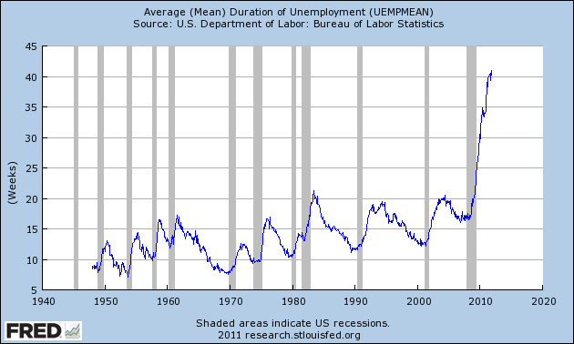

The count today is 40.9 weeks - a new record.

The next graph, from the same source, reflects total employed (nonfarm). The time frame is shorter spanning from January 2000 through November 2011.

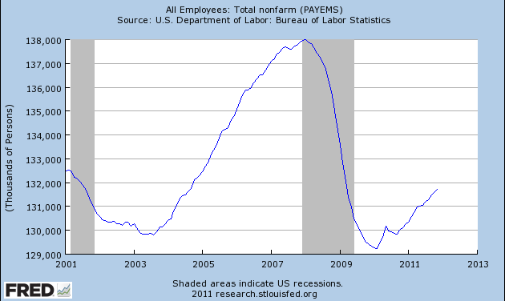

There are less jobs today than there were on January 1, 2000.
There are approximately 30 million more people, in this country, today than on January 1, 2000.
Those that have a job today are working longer than in the past (and, not leaving an opening for the young).
The combination of those three points makes it perilous for anyone desiring to find work today.

NACE and college graduates search for employment
Established in 1956, the National Association of Colleges and Employers (NACE) is the leading source of information on the employment of the college educated. Simply stated, NACE is a subscription service that tracks college graduates - how many are being hired and what they are being offered, by major. Their work is frequently cited by major news services such as CNN.

Their measurement date is May, since that is the traditional graduation month. Right on schedule, a NACE press release dated May 2011 contained the following (underline added for emphasis):

More than 56 percent of computer science majors who have applied for a job have received an offer making it the major with the highest offer rate from the Class of 2011.

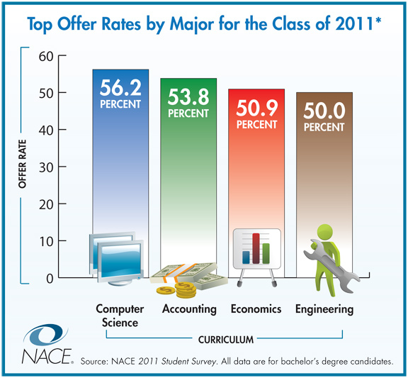

If the reader looks at the only four majors where 50% or more of job seekers were offered employment, they will notice some of the most rigorous majors a student can choose.

From the same press release, the following was also found: ... education (19.5 percent), English (23.5 percent), and healthcare (28.7 percent) had weak offer rates.

Being offered a position and having a job are two different matters.
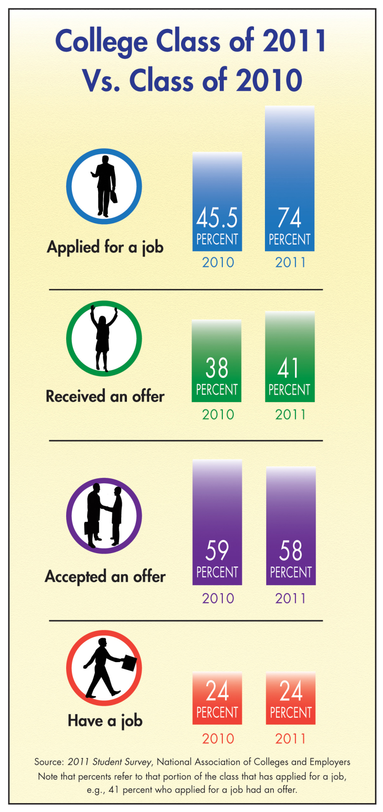

The above is from another May 2011, NACE press release.
Suggestions to students
The following are suggestions the author gives to his students. The reader should feel free to steal or dismiss the following:

Suggestion One
The job market, for current graduates, is very tight. With increased enrollment in higher education, it does not figure to improve dramatically in the next four years. As you go through college, add a line to your resume as often as possible - starting immediately. Picture, in your mind, what your resume will look like at graduation. Yes, in the case of most students, the distance to graduation would be measured in years. If you do not start now, two months from graduation will be too late to "paint" your resume.
The employment situation has changed dramatically in the past half-decade. Your resume will need to beat a large stack competing for the same position. You can help it rise to the top by starting now.
This instructor's current students include one that does volunteer tutoring for other students, one that takes notes for a disabled student and one that has volunteered on the weekend at her church counting the collection - to name a few. Any one of those plays extremely well in pushing that student's resume closer to the top. It certainly trumps the alternative of being fully engaged with the reality offerings on the flat screen, having an overactive Facebook account, being able to text 70 words per minute, or professing a high kill rate on Call of Duty.

Suggestion Two
If you are looking for a part-time job while pursuing your degree, a prudent choice might be the banks, credit unions or credit card companies.
Those employers are very good at scheduling around students' classes (they understand).
Many (not all) of those places have tuition reimbursement programs for their employees. This helps with saving the student money while they continue their education.
The job situation is not good for college graduates. All of those places have "college level" jobs upon graduation. If you are challenged to find a job when you graduate - you have a "backup" plan. You can attempt to move up and continue working full-time at the bank, credit union, or credit card company.
Obviously, there are not enough of these jobs available for all of MCCCD's students. Be grateful this was sent to a select group.

Suggestion Three

Does the current student meet all of the following conditions?

1) Will be graduating from college with student loans.
In fiscal 2006, aid from student loans at the three State universities was $458.5 million. By fiscal 2010, that amount had grown to $731.8 million - an increase of almost 60% in four years. Currently, 81% of State university students receives some type of financial aid.

2) Currently live at home.

3) Have a healthy relationship with their parent(s).

This suggestion is called only trying to juggle two balls at once.
Suggestion: Stay at home until your student loans are paid off.

If the student is fortunate enough to secure employment at graduation, here is what their life will look like if they move out on their own:
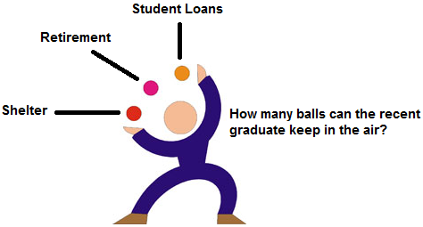
Transportation, insurance, entertainment and perhaps, food, would be a constant regardless of where the graduate lives. Utilities, cable, property taxes and the like are an added expense when leaving the nest. Shelter makes for a third, and heavy, financial ball to juggle.
As referenced earlier, retirement is becoming more and more elusive. The future of Social Security is unknown. Planning for the worst - self-sufficiency in retirement - and leaving the workplace with your health intact is a noble goal.
The author has been using the following for many years in his classes:
Individual one invests a fixed amount, at the beginning of each of ten years, at 6% - and then stops investing. From year eleven forward, the nest egg continues to earn 6% annually.
Individual two does nothing for the first ten years. In year eleven, this individual begins investing the same fixed amount each year, as individual one, at a return of 6% annually.
Regardless of the amount chosen, as long as it is the same for both individuals, their savings will finally equal in year 37.
Moral to the story: The earlier you start thinking about retirement, the less saving (sacrifices) you will need to make later. This is why Albert Einstein called compound interest the eighth wonder of the world.
Aside: In 1999, this instructor met bewildered looks of: 6% per year, that's all, I can do better than that. After 2000, the voices had changed to: where can I get 6%? Currently, with the housing implosion and tuition explosion, it appears that there is little available to invest.
An eye to retirement and a bigger eye to paying off that non-dischargeable student loan debt will assure that when they move out on their own, they will only have two balls in the air at any time.
Just so the student doesn't feel so alone, the following was found in the 2010 Census:
Roughly 5.9 million Americans 25-34 last year lived with their parents.
Given current wage levels, providing for one's own shelter and retirement is enough to do without the burden of student loans compromising either of those or some of the other things in life that individuals enjoy.
Saving implies sacrifice. Sacrificing for a few years while you are young - by staying home - will reap benefits for decades into the future. With this approach, the American Dream is still possible. The game of life has changed and with that a different approach is needed.

