**Lab Techniques: click each title (link) to read instructions on proper technique for each procedure.** Some techniques were written using <https://chem.libretexts.org/Core/Analytical_Chemistry/Lab_Techniques> as a resource.

* [Handling chemicals](#HandlingChemicals)
* [Lab Safety](#LabSafety)
* [Common lab glassware](#Glassware) and equipment
* [Significant figures](#Significantfigures)
* [Showing calculations in your report](#ShowingCalculations)
* [Preparing solutions](#PreparingSolutions)
* [Using an analytical balance](#Usingananalyticalbalance)
* [Reading a meniscus in various pieces of glassware](#Readingmeniscus)
* [Transferring solids](#Transferringsolids)
* [Transferring liquids](#Transferringliquids)
* [Separating a liquid from a solid](#Separatingliquidsolid)
* [Using a Bunsen burner](#Bunsenburner)
* [Using a centrifuge](#Centrifuge)
* [Pipetting a solution](#Pipetting)
* [Using a buret to deliver solution](#Usingaburet)
* [Performing a titration](#Titration)
* [Litmus paper test for acids and bases](#Litmustests)
* [Using and calibrating a pH probe](#pHprobe)
* [Graphing and trendlines](#Graphing)

**Handling chemicals**

[Return to top](#Lab%20Techniques)

When handling chemicals in lab, proper safety precautions should always be taken. Much of these notes were used or adapted from: <https://chem.libretexts.org/Core/Analytical_Chemistry/Lab_Techniques/Safety>

**I. Appropriate attire for lab**

* Shorts, skirts, and open-toed shoes are never to be worn in the lab.  You should also not wear anything that has strings or sashes coming off it, such as hooded sweatshirts, or flowing tops.  Full sleeves are not recommended, as they can easily be dragged over dirty bench-tops and get contaminated or knock over chemicals or glassware.
* Closed toed shoes that cover the entire top of the foot and back of heel should be worn in lab.  Also choose a shoe that does not have any decorative holes and are non-slip.
* Jewelry should not be worn.  Rings and bracelets are easily contaminated, and some reagents will actually react with the metal or even the stone.  Necklaces are less of a problem, unless they are very long and will dangle over your workstation.
* Long hair should always be tied back so it does not drag in your reaction or any spills that may occur.
* You should only wear clothing in the lab that you would not be sorry to lose.  This means don't wear that priceless silk/angora sweater you got for your birthday, or that awesome new pair of sneakers.  If there is a spill, usually clothes are damaged.  Wear simple, sturdy items.
* Lastly, in case of accidents, it can be helpful to store an extra shirt and pair of pants in your backpack or car. You never know when a spill or fire may occur, even if you yourself are vigilant about safety.

**II. Chemical Labels**

* Read labels on reagent bottles **twice** before using chemicals. Refer to techniques on [transferring liquids](#Transferringliquids) and [transferring solids](#Transferringsolids) for best practices to transferring chemicals. Avoid using excess reagents. ***NEVER return excess reagents to the reagent bottle.*** Place any excess reagent into the appropriate waste container.
* Never smell, taste, or touch a chemical unless directed to do so. Skin, nose, and/or eye irritation can occur with many chemicals used in lab. NEVER handle chemicals, equipment, or glassware until appropriately protected with clothing, goggles, shoes, and hair tied back.

**III. Waste**

* Discard of chemical waste in the designated container. Your experiment and instructor will both discuss where chemicals should be disposed. If in doubt, it is better to ask than assume!
* Waste containers are usually stored in the fume hoods to avoid exposure to hazardous chemicals. Waste disposal codes sometimes require that chemicals be stored separately before disposal. Always check labels on waste containers to ensure the correct chemicals are being disposed of. Solid, non-chemical waste (paper products like litmus paper, filter paper, and matches) can be disposed of in the appropriate waste container.
* The next page discusses special considerations:

**Things That Should Never Go Down the Drain:**

These materials should be disposed of in properly labeled liquid waste bottles.

* Heavy metal containing solutions
* Organic/halogenated solvents
* Strong, undiluted acids and bases
  + These can cause physical damage to the plumbing. Use bicarbonate to neutralize acids, and dilute sulfuric acid to neutralize bases. Check the pH with a strip. When it is neutral it is often okay to dispose of them down the drain with sufficient tap water to flush them.
* Biohazardous liquids - It is often acceptable to decontaminate some biohazardous solutions with bleach or similar disinfectants and dispose of them down the drain, others must be autoclaved.

T**hings That Should Never Go in the Trash:**

* Sharps - Special containers should be available for needles and broken glass
* Biohazardous Solids - These usually must be autoclaved. Make sure you are using autoclavable bags/containers to do so
* Anything on the previous list

**Special Considerations:**

Consult a list of chemical incompatibilities before adding a chemical to a waste bottle. Some incompatibilities are:

* Bleach and chlorine
* Acetone and concentrated nitric acid
* Cyanide and acid
* Chemicals which are reactive or pyrophoric can not be simply disposed of and must be [quenched](https://chem.libretexts.org/Core/Analytical_Chemistry/Lab_Techniques/Quenching_reactions).

Some chemicals are not particularly hazardous, but have unpleasant odors. These should be destroyed before placing them in waste containers exposed to the laboratory environment. Some examples are:

* Sulfides, disulfides, thiols - These can be destroyed (through oxidation) with bleach
* When left exposed to the atmosphere for long periods of time, some chemicals form peroxides which can detonate when disturbed. Stocks of these chemicals should be periodically rotated. Some peroxide forming materials are:
* Ethers - especially diisopropyl ether
* Molecules with benzylic or allylic hydrogens

**Lab Safety**

[Return to top](#Lab%20Techniques)

**I. Laboratory Equipment**

Know the location of pertinent safety equipment in the lab. These include fire extinguishers, fire blankets, eyewash stations, safety showers, gas shutoff valves, and evacuation maps.

* Fire Extinguishers:  In the event that a small fire breaks out in the lab, turn off the gas to your Bunsen burner immediately.  Seek the help of your instructor and they will determine whether a fire extinguisher is appropriate to put out the fire or if the laboratory room needs to be evacuated.
* Fire Blankets:  In the event that your clothing or your lab partner's clothing catches fire, a fire blanket can be used to help extinguish the fire.  Have the person stop, drop, and roll and smother the fire with the fire blanket.
* Eyewash station:  Turn on the water and flush your eyes out by rolling them around in the water for at least 10 minutes.  You should not be wearing contacts in the lab but if you are take them out immediately.
* Safety Shower:  The safety shower is used to wash any spilled chemical off your person if it is a large quantity or in an area that a sink could not rinse the chemical off.  The safety shower can also be used to put out any type of clothing or hair fire.
* Gas Shutoff Valves:  Each lab bench has a gas shutoff valve.  In the event of a fire or an incident where the laboratory room needs to be evacuated, make sure the gas is completely turned off to each valve on your benchtop.
* Evacuation Maps:  Evacuation maps are located next to each exit for the laboratory room.  In the event that the lab room needs to be evacuated make sure you meet at your designated location so that you can be accounted for by your instructor.  If you do not go to the designated location it might be assumed you are still in the building and in danger.  This could result in various rescue efforts looking for you.

Always wear appropriate eye protective wear in the laboratory classroom at all times as long as one person is still working on an experiment.  It is an Arizona State Law:

Arizona Statute ARS15-151 specifies that every student, teacher, and visitor in public and private schools, community colleges, and universities shall wear appropriate eye protective wear while participating in or when observing vocation, technical, industrial arts, art or laboratory science activities involving exposure to: molten metal or other molten materials, cutting, shaping and grinding of materials, heat treatment, tempering or kiln firing of any metal or other materials, welding fabrication processes, explosive materials, caustic solutions, radioactive materials.

Images for Correct Eye Protective Wear – OSHA Z87 ratings:

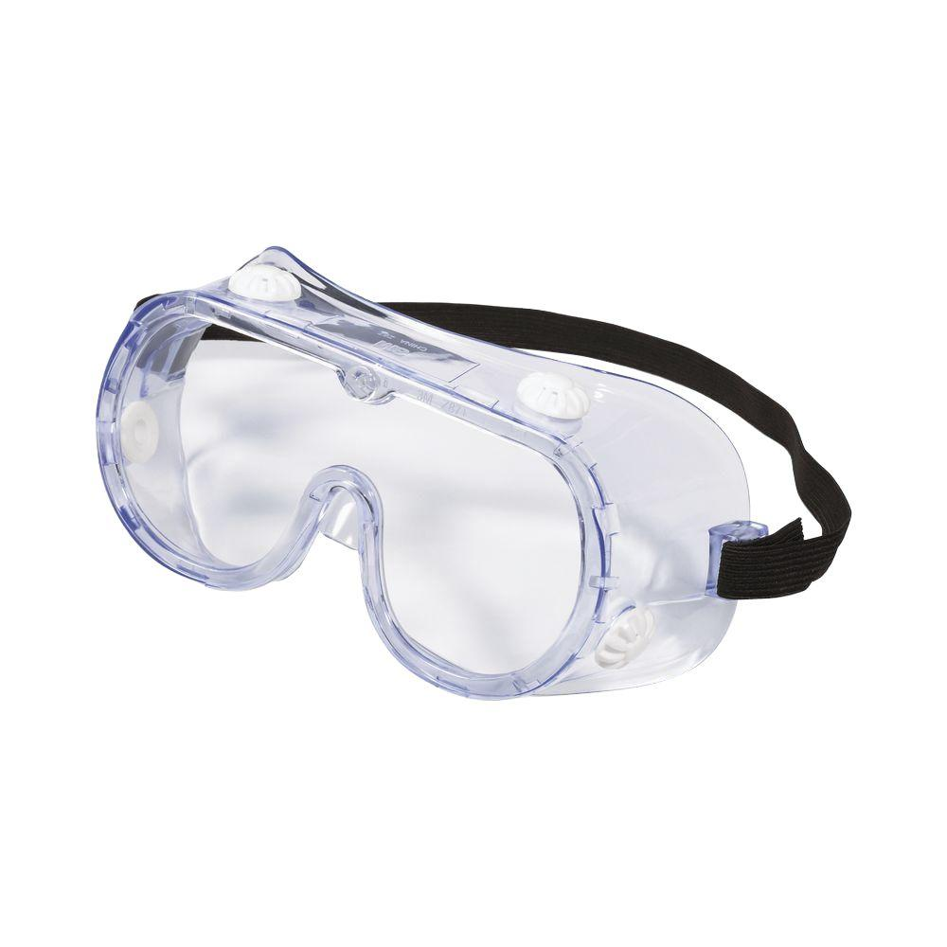

Safety Warning Labels:  Occupational Safety and Health Administration (OSHA) Hazard Pictograms are used to identify particular safety hazards for chemicals used in the lab.  Refer to the OSHA website listed here for these images:  <https://www.osha.gov/Publications/HazComm_QuickCard_Pictogram.html>

**II.  Chemistry Department Safety Rules**

1)  Wear approved goggles at ALL TIMES in the laboratory. Do not open the goggle vents.

2)  Do not perform unauthorized experiments. Only your laboratory instructor may authorize special experiments.

3)  Wash any spilled chemicals off your person with water as quickly as possible.

4)  Do not touch any chemicals without receiving specific instructions to do so from your instructor.

5)  Do not taste any chemicals.

6)  No food or drinks are allowed in the laboratory room at any time.

7)  Smell chemicals only when directed and then with caution.

8)  Insure that any heated glass or metal equipment has cooled adequately before handling.

9)  Use caution in handling all glassware. If a cut occurs, rinse the wound with cold running water until you are sure there are no small pieces of glass in the cut.

10)  Before you plug in electrical equipment, make sure that the cords are not damaged. Keep cords away from all hot surfaces.

11)  Know your laboratory’s location for the fire extinguisher, eye bath, and shower.

12)  Wear closed-toe shoes and appropriate clothing that covers the student from neck (including shoulders) to below the knees. Jeans with any holes from the knee up are not allowed.

13)  Keep long hair (neck length and longer) tied back at all times.

14)  Consult the lab procedure for handling waste chemicals.

15)  You are responsible for cleaning the equipment you use as well as your lab workstation

16)  You must wash your hands with soap and water and wipe your lab bench down with a damp paper towel after every lab.

17)  Report any personal injury, no matter how slight, to your laboratory instructor.

18)  Always read your laboratory exercise completely prior to actual lab time. Be aware that an unprepared worker is an unsafe worker.

19) Upon request, we can provide a list of chemicals used for the semester, as well as the SDS reports.

**Common lab glassware and equipment**

[Return to top](#Lab%20Techniques)

|  |  |  |  |
| --- | --- | --- | --- |
| Beakers | GCC DISC:CHM 152LL:CHM152LL F17:Techniques Pics:Beakers_2.jpg | Watch glass | GCC DISC:CHM 152LL:CHM152LL F17:Techniques Pics:WatchGlass copy.JPG |
| 10 mL Graduated cylinder | GCC DISC:CHM 152LL:CHM152LL F17:Techniques Pics:10mlGradCylin copy.JPG | Evaporating dish | GCC DISC:CHM 152LL:CHM152LL F17:Techniques Pics:EvapDish copy.JPG |
| 100 mL Graduate cylinder | GCC DISC:CHM 152LL:CHM152LL F17:Techniques Pics:100mLGrad copy.jpg | Bunsen burner | GCC DISC:CHM 152LL:CHM152LL F17:Techniques Pics:Bunsen copy.JPG |
| Spatula |  | Scoopula |  |
| Erlen-meyer flasks | GCC DISC:CHM 152LL:CHM152LL F17:Techniques Pics:Erlenmeyers copy.JPG | Stirring rod with rubber policeman |  |
| Volumetric flask | GCC DISC:CHM 152LL:CHM152LL F17:Techniques Pics:VolFlask copy.JPG | Hot plate/Stir plate (with buret stand) | GCC DISC:CHM 152LL:CHM152LL F17:Techniques Pics:Stirplate&Stand copy.JPG |
| Volumetric pipet | GCC DISC:CHM 152LL:CHM152LL F17:Techniques Pics:VolBuret copy.JPG | Iron support ring | GCC DISC:CHM 152LL:CHM152LL F17:Techniques Pics:SupportRing copy.JPG |
| Pipet pump | GCC DISC:CHM 152LL:CHM152LL F17:Techniques Pics:PipetPump copy.JPG | Digital Thermo-meter | GCC DISC:CHM 152LL:CHM152LL F17:Techniques Pics:DigitalThermo copy.JPG |
| Buret | GCC DISC:CHM 152LL:CHM152LL F17:Techniques Pics:GradBuret copy.JPG | Buret stand and clamp | GCC DISC:CHM 152LL:CHM152LL F17:Techniques Pics:BuretClamp1 copy.JPG |
| Plastic (beral) pipet | GCC DISC:CHM 152LL:CHM152LL F17:Techniques Pics:PlasticPipet copy.JPG | Mortar and pestle | GCC DISC:CHM 152LL:CHM152LL F17:Techniques Pics:Mortar&Pes copy.JPG |
| Analytical Balances | GCC DISC:CHM 152LL:CHM152LL F17:Techniques Pics:Balance copy.JPG |  |  |
| Centrifuges | GCC DISC:CHM 152LL:CHM152LL F17:Techniques Pics:Centrifuge copy.JPG |  |  |

**Significant figures**

[Return to top](#Lab%20Techniques)

Every measurement has a degree of uncertainty associated with it. The uncertainty derives from the measuring device and from the skill of the person doing the measuring.

(This section adapted from http://chemistry.about.com/library/weekly/aa082701a.htm)

If you need to measure 7 mL of water, you could use a beaker that is marked in 5 mL increments. With this beaker, you could estimate a volume between 5 and 10 mL, and probably measure an amount close to 7 mL (within 1 mL). If you used a buret marked to 0.1 mL increments, you could measure a volume between 6.99 and 7.01 mL more reliably. The precision of your measurement is expressed by using the appropriate number of significant figures. The significant digits include the digits you can clearly read, and the last digit which is estimated.

**Determining the number of significant figures in a reported measurement**:

* Non-zero digits are always significant (e.g., 549 cm).
* Zeroes between non-zero digits are significant (e.g., 1025 mL).
* Zeroes at the end of a number that contain decimal point **are** significant (43.21000 g).
* Zeroes at the beginning of a number **are not** significant (e.g., 0.00482 m). You can always determine which digits are significant by rewriting this number in scientific notation. Leading zeroes do not appear when numbers are written in scientific notation.
* Zeroes at the end of a number and before the decimal point (5300) are assumed to not be significant. If they are significant, the number should be reported in scientific notation so that the significant zeroes are after the decimal place. 5300 would be written 5.300 x 103.

**Uncertainty in Calculations**:

Measured quantities are often used in calculations in lab. The precision of a calculation is limited by the precision of the measurements on which it is based.

* **Addition and Subtraction:**   
  When measured quantities are used in addition or subtraction, the final answer is limited by the **last decimal place in which all digits are significant.** In this example, The tenths place (one after the decimal place) is the last significant digit.

Example: 32.01 m + 5.325 m + 12.1 m = 49.435 m  
  
The sum of the numbers is 49.435, but the sum should be reported as 49.4 meters because 12.1 m is only known to the tenths place.

* **Multiplication and Division:**   
  When experimental quantities are multiplied or divided, the answer is limited by the number in the calculation with the fewest **number of** **significant figures** than any of the original numbers.

Example: 25.624 g / 25 mL = 1.02616 g/mL

Your calculator will read 1.02616, but the final answer should be reported as 1.0 g/mL because 25 mL only has 2 significant digits.

**Showing calculations in your report**

[Return to top](#Lab%20Techniques)

**ALL** calculations must be shown for EACH type of calculation performed during an experiment. To receive full credit for your calculations, the following format should always be used

* Write down any formulas that you use in your calculations.
* Each step in the calculation should be shown clearly.
* Report the result of the calculation with units (unrounded)
* Report the final answer, with units, to the correct number of significant figures.



***Example:***  A = l x w

A = 2.34 cm x 1.2 cm

A = 2.808 cm2

A = 2.8 cm2

**Common formulas:**

Density = mass / volume

% error **=** 

Volume by displacement or delivered from a buret: Vtotal = Vfinal - Vinitial

Dilution formula: M1V1 = M2V2

Where M1 is the initial (stock solution) concentration or molarity

V1 is the volume of stock solution used

M2 is the final concentration or molarity after dilution (must be lower than M1)

V2 is the total volume of all solutions and liquids

Note: Concentrations and Volumes can be in any units as long as they are the same before and after, i.e., both volumes in mL, drops, L, etc. and both concentrations in M, mg/mL, etc.

**Preparing solutions**

[Return to top](#Lab%20Techniques)

Solution preparation in lab is very common. You might be asked to make a solution starting with a solid reagent or an aqueous solution. The proper sequence of events is outlined below for both scenarios.

**Starting with solid reagent:**

1. Choose a volumetric flask that is the correct total volume for the solution to be made (e.g, 100 mL) Add a small amount of DI water to the volumetric flask (about 1/3 full).
2. Calculate the mass of reagent (solute) needed to make the desired concentration.
   1. You will need to calculate the number of moles of reagent from the concentration and volume of solution. Use the molar mass of the solid to calculate the mass to be measured.
3. Measure out the correct mass of reagent to be used. Refer to the “[Using an analytical balance](#Usingananalyticalbalance)” technique for more details. Do not insert a pipet, spatula, scoopula, or other equipment directly into a reagent container. Pour a small amount of solid into a beaker, weighing boat, or weighing paper; adjust mass as needed, pouring excess reagent into a waste container – NEVER back to the reagent bottle or jar. Refer to the “[Transferring solids](#Transferringsolids)” technique for more information.
4. Slowly add the measured mass of solid to the volumetric flask while swirling.
5. Cap the flask and vigorously swirl the solution to ensure all solid is dissolved.
6. Fill the volumetric flask to the line (the bottom of the meniscus is at the line). With a stopper secured in place with your thumb or fingers, gently invert the flask several times to ensure the solution is thoroughly mixed.

**Starting with an aqueous solution:**

1) Repeat the procedure as above, but in step 4 you will use a measured volume of concentrated solution. Refer to the “[Transferring liquids](#Transferringliquids)” technique for more information. The solution can be accurately measured in a graduated cylinder.

**Using an analytical balance**

[Return to top](#Lab%20Techniques)

**Balances**: In most chemistry labs, balances are used to determine the mass of a sample. These balances are very expensive, very sensitive, and must be used very carefully to avoid damage.

The most important rule is NEVER place any chemical directly on the balance pan. Use a DRY beaker, watch glass, plastic weighing cup, or weighing paper.

• The balances are to remain “ON” at all times.

• All doors or lids are to remain closed at all times, except when loading or unloading the balance.

• Do not lean on the balance table. (The balance is sensitive enough to measure vibrations on the countertop due to students leaning on it.)

• Material to be weighed should be placed **in a container** on the balance pan. The container may be either pre-weighed or “tared” or zeroed out (as described below).

• Before weighing, be sure the doors/lid are closed and the digital scale reads all zeros. If zeroes are not displayed on the scale, gently click the zero/tare button or bar until the balance displays all zeros.

• To weigh an item, open the door, and carefully place the container with the chemical or item on the center of the pan. Close all doors/lid on the balance. Wait 3 – 5 seconds for the mass to stabilize and read/record all the numbers in the digital readout. Never round any numbers reported on any electronic instrument. Remove the container and close the doors/lid before leaving.

• **Taring a container**: If you are using a container to hold chemicals, you may tare or zero the container. To do that, place the container carefully in the center of the pan. Briefly click on the zero button or bar. Zeros should appear. The container is now “tared out,” and the balance is set to read the weight of any material added to the container. Remove the container from the balance, add material to it, and carefully place the container back on the center of the pan and close all doors/lid. (Do NOT re-zero the balance during this process.) Read the digital scale when stabilized as before. After you have removed the container, shut the doors and gently push the zero button to remove the tare and return the scale to zero.

**Reading a meniscus in various pieces of glassware**

[Return to top](#Lab%20Techniques)

**Graduated Cylinders:** These are used to contain and deliver measured amounts of liquid. When water is placed in a glass cylinder, a concave surface forms; this curve is called the meniscus. Glass graduated cylinders are manufactured so that the line at the bottom of the meniscus gives the most accurate reading. In order to read any graduated cylinder accurately, it must be level (sitting on the counter, NOT hand-held). Your eye must also be perpendicular to the water level.

**Picture here:**

• The 10-mL graduated cylinder above is read to two decimal places (to the nearest 0.01 mL). Thus, the volume of liquid is read to be 2.77 mL.

**Picture here:**

• Note that 100-mL graduated cylinders have markings for each mL, so they are read to one decimal place (to the nearest 0.1 mL).

Pipets: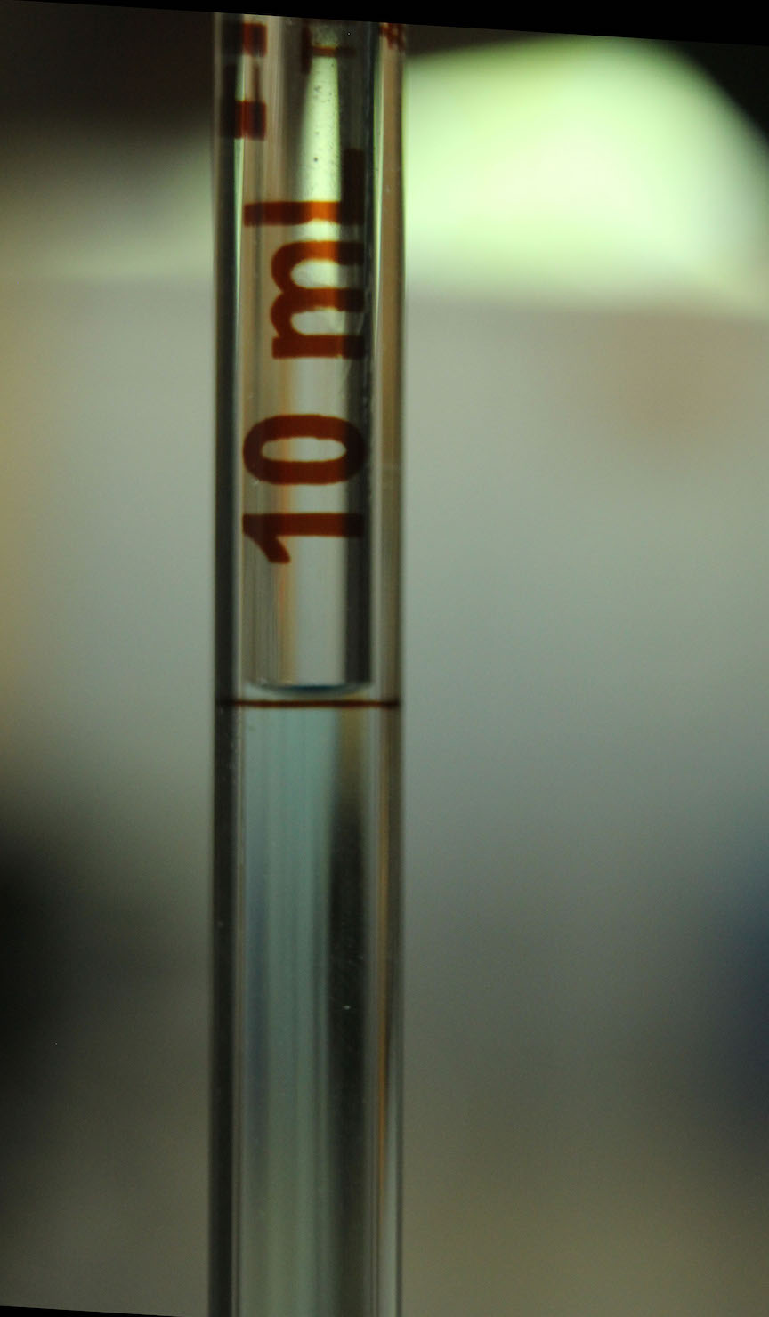 burets: 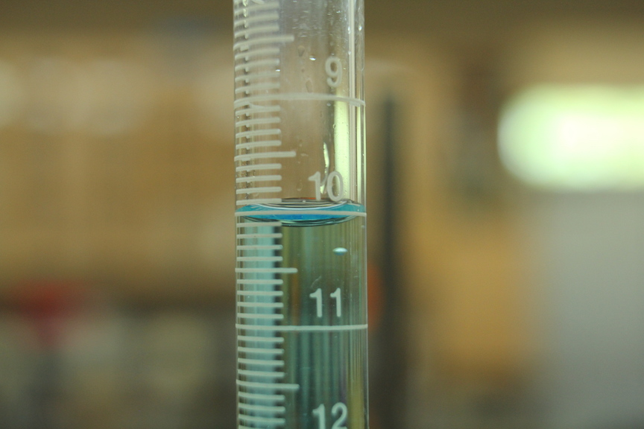

Volumetric flasks: Beakers:

**Transferring solids**

[Return to top](#Lab%20Techniques)

Before transferring a solid for use in an experiment or to make a solution, read the label twice! Be sure you are using the correct chemical.

If the reagent bottle has a glass stopper or a screw cap, place the stopper top side down on the bench to prevent transferring chemicals to the bench.

Take a beaker with you to collect your solid reagent. Hold the reagent bottle with the label against your hand. This prevents chemicals spilling on the label and smearing or distorting the name, formula, or information. Dispense only as much reagent as is needed. NEVER return excess to the reagent bottle. DO NOT insert a spatula, scoopula, or any other object into the reagent bottle. These will contaminate the solid.

Be sure to recap the reagent bottle when you are done dispensing solid.

**Transferring liquids**

[Return to top](#Lab%20Techniques)

Before transferring a liquid for use in an experiment or to make a solution, read the label twice! Be sure you are using the correct chemical.

Take a beaker with you to collect the liquid or solution.

If the bottle has a coin top stopper, grip the stopper upside down in between the first and second fingers of your pouring hand. Insert picture here? This will allow you to hold the bottle and avoid setting the stopper on the bench. If the reagent bottle has a glass stopper or a screw cap, place the stopper top side down on the bench to prevent transferring chemicals. Hold the reagent bottle with the label against your hand. This prevents chemicals spilling on the label and smearing or distorting the name, formula, or information.

If the reagent bottle has a large mouth opening, hold a stirring rod again the lip of the opening and pour the liquid down the stirring rod into your beaker.

Insert picture here

Dispense only as much reagent as is needed. NEVER return excess to the reagent bottle. DO NOT insert a spatula, scoopula, or any other object into the reagent bottle. These will contaminate the solution.

Be sure to recap the reagent bottle when you are done dispensing solution.

**Separating a liquid from a solid**

[Return to top](#Lab%20Techniques)

There are several techniques that can be used to separate a liquid and a solid if the solid is not dissolved. The two most common ones used in General Chemistry labs are described below.

A) **Decanting**: If the solid is clearly separated from the liquid and settled on the bottom of the glassware (beaker, test tube, etc.):

1) Without agitating the solid, slowly pour the liquid (supernatant) to a new glass container.

B) **Gravity filtration**: If the solid does not dissolve in liquid but is not settled at the bottom, filtration must be used to separate the two.

1) Fold a round piece of filter paper in half; fold in half again. Separate the filter paper with one layer on one side and three layers on the other side. Insert picture here.

2) Place the folded filter paper snugly into a funnel. Moisten the filter paper using a DI wash bottle. This will help seat the paper in the funnel without popping out.

3) Transfer the liquid through the funnel. Slowly fill the funnel less than two-thirds full. Pour slowly enough that liquid does not rise over the top of the filter paper. Keep the funnel stem full with filtrate; the weight of the filtrate creates a slight suction that helps speed up the filtering process.

**Using a Bunsen burner**

[Return to top](#Lab%20Techniques)

A Bunsen burner uses gas to produce a flame that can then be used to heat substances in lab. When

used properly, Bunsen burners are a safe and efficient source of heat.

Rubber tubing is used to connect the Bunsen burner to a gas supply. Check the tubing for holes or

cracks before connecting. You will need to use a striker or match to light the Bunsen burner.

Insert labeled picture of Bunsen burner

1) Clear the area around the Bunsen burner of any flammable materials. Ensure that nothing is above the Bunsen burner.

2) After checking the rubber tubing for holes or cracks, connect it to the gas valve at the bench and the Bunsen burner.

3) Open the gas flow regulator dial at the base of the burner about one full turn.

4) Rotate the barrel sleeve (the vertical post of the Bunsen burner) to close the air supply holes completely.

5) Have a striker or lit match ready; open the gas valve at the bench (turn left to turn it on).

6) Light the burner. Be sure the striker is producing sparks as you strike it. IF YOU CANNOT LIGHT THE BURNER, TURN OFF THE GAS! Ask your lab instructor to help you light the burner. The flame will be yellow at first.

7) Once lit, rotate the barrel sleeve to the left to open the air holes. The flame will turn a blue shade and become more intense.

8) Adjust the Gas Flow Regulator and Air Inlet Holes to achieve the desired height and intensity of flame. 1-2 inches is usually a good height, but air flow in the lab may require a larger flame.

9) You should see two blue zones in the flame. Just above the tip of the inner cone is the hottest part of the flame and should be used to heat substances.

**Heating a beaker:**

Set up a ring stand and metal ring (or clay triangle) with wire gauze. Light the Bunsen burner and then adjust the height of the metal ring before moving it over the burner. Then place the beaker with solution or substance to be heated on the wire gauze. If a large beaker is used, a support ring can be clamped to the ring stand and placed around the top of the beaker to avoid having it fall over.

Insert picture here

**Heating a test tube:**

A test tube holder (or clamp) must be used to heat the solution or substance in a test tube. Hold the test tube at an angle pointed away from your, students’, and your instructor’s faces. **NEVER** point the opening of a test tube toward anyone! Move the test tube circularly in and out of the flame, heating from top to bottom. Move the test tube back and forth in the flame to avoid overheating in one spot. Do not stopper a test tube while it is being heated.

Insert picture here

**Using a centrifuge**

[Return to top](#Lab%20Techniques)

Centrifuges are used to help separate a solid from a liquid. A centrifuge has holders for test tubes angled outward. When it spins at a high rate, solids are pulled to the bottom of a test tube. Because it spins at such high speeds, several precautions must be taken to ensure safe usage and avoid breaking test tubes. After centrifuging, the supernatant can be easily decanted into a new container.

Balance test tubes by placing them across from one another. Some centrifuges will have numbers at each opening. You should make a note of which two positions you use as multiple groups might be sharing a centrifuge. If possible, label your tubes to identify which one is yours and which tube it is (if centrifuging multiple tubes).

Test tubes are balanced by placing two test tubes with roughly equal volumes directly across from each other. If only one test tube needs to be centrifuged, a roughly equal volume of water should be used in another tube.

Test tubes should never be filled to a height more than one centimeter from the top.

Be sure to close the lid before starting. NEVER walk away from a spinning centrifuge. If you hear a cracking sound, immediately stop the centrifuge. Wait for it to stop spinning before opening the lid.

**Pipetting a solution**

[Return to top](#Lab%20Techniques)

Video: <https://www.youtube.com/watch?v=Zq1kY0qLpMk&feature=youtu.be>

**Conditioning a pipet:**

To use a pipet you must first clean and condition it. Assume it is dirty from the last lab.

1. Rinse with distilled water thoroughly three times.
2. Condition with the solution to be measured by drawing a small portion of that solution into the pipet. **Loosely** place with a pipet pump with a plastic wheel (or pipet bulb) on top of the pipet. Draw solution about halfway up the pipet by rolling the wheel with your thumb (or forefinger). Solution should fill the bulb – the wide part – about halfway. Quickly cap the top of the pipet with your thumb while simultaneously pushing the pump off with your thumb.
3. Roll the solution around inside the pipet and empty through **both ends** to ensure the inside of the pipet is coated with the solution.
4. Repeat two more times for a total of three times.

**Measuring volume with a pipet:**

1) Loosely place the pump on top of the pipet again to draw solution well above the “mark” on the pipet. Take care NOT to suck the solution all the way up into the pump. Simultaneously push the pump off with your thumb while capping the top of the pipet.

2) Gently roll your thumb to lower the solution to the “mark” exactly. The bottom of the meniscus must be exactly at the “mark”. Be sure that the tip of the pipet is not resting on the bottom of the beaker when you measure this. Otherwise, the level of the meniscus will change when you raise the pipet.

3) Dispense the solution into the flask by removing your thumb and letting it drain into the glassware (Erlenmeyer flask or beaker) to be used. Allow an extra 10-20 seconds for all solution to drain out. Touch the end of the pipet to the side of the glassware to remove the last drop.

1. Note: **DO NOT** force out the small amount of liquid remaining in the tip of the pipet. Pipets are calibrated to retain this amount.

Insert pictures here (bottom of pipet off bottom of beaker; thumb on top of pipet, liquid at mark)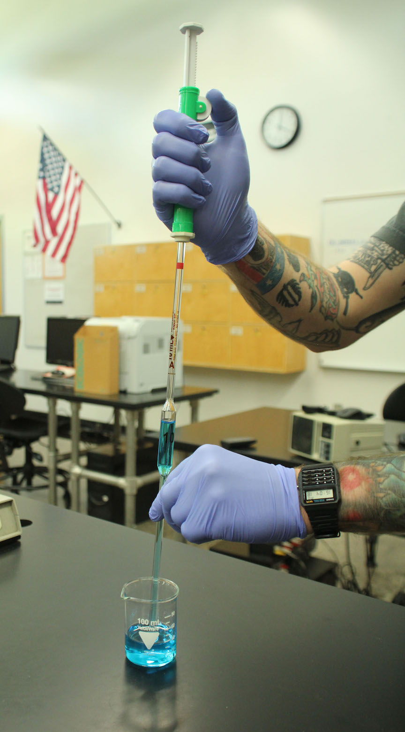 

**Using a buret to deliver solution**

[Return to top](#Lab%20Techniques)

Video: <https://www.youtube.com/watch?v=meT4rE6CVpI&feature=youtu.be>

**Conditioning a buret:**

To use your buret you must first clean and condition it. Assume it is dirty from the last lab.

1. Rinse with DI water thoroughly three times and let it drain through the tip.
2. Condition with the solution to be put in the buret by pouring a small portion of that solution into the buret with the stopcock closed. Roll the solution around inside the buret and empty through **both ends** to ensure the inside and the tip of the buret are coated with the solution.

Repeat this process two more times for a total of three rinses with the solution you want in the buret.

* 1. Note: If solution does not drain through the tip, it is because there is not enough air pressure within the buret to push it through. Simply add a few more milliliters of solution to drain through the tip.

**Using a buret to deliver solution:**

1. Secure the buret with a buret clamp on a ring stand. Ensure the buret is perpendicular to the bench and not angled.
2. Close the stopcock and fill the buret with the solution to just above the 0.00 mL mark. Open the stopcock to drain a small amount of solution into a waste beaker so it fills the tip with solution.
3. Be sure no air bubbles are present in the tip of the buret. If there is an air bubble in the tip of the buret, open the stopcock parallel to the buret to let solution flow through.
4. If the air bubble does not come out after a few seconds, you will have to drain the entire solution through the tip (into your solution beaker/flask since your buret has been conditioned), close the stopcock, refill the buret with solution, and open the stopcock to drain solution through the tip again. The bubble should pop on the second drain.
5. Drain solution through the tip until the solution level is below the zero mark.
6. Read and record the initial volume as accurately as possible (2 decimal places).

**Performing a titration**

[Return to top](#Lab%20Techniques)

Video: <https://www.youtube.com/watch?v=Hfhv7dx__1M&feature=youtu.be>

A titration is a technique used to accurately and precisely standardize (calculate the concentration of) an unknown solution. A minimum of three good trials (volumes used are close to each other) is needed to ensure a good result.

Refer to the “[Using a buret to deliver solution](#Usingaburet)” technique to prepare a buret for titration. The solution in the buret is the titrant.

Prepare the solution in an Erlenmeyer flask or beaker. If using a solid reagent, refer to the “[Preparing solutions](#PreparingSolutions)” technique starting with solid reagent. If using an aqueous reagent, refer to the “[Pipetting a solution](#Pipetting)” technique.

Because most solutions used in titrations are clear and colorless, an indicator is often used. Phenolphthalein is the most common one – it is colorless in acidic solutions and pink in basic solutions. Only 2-3 drops of indicator need to be used in titrations. The lightest color change is desired so the end point is as close to the equivalence point (determined by calculation) as possible. It is common practice to work on a white stir plate or on a white piece of paper. This makes the subtle color change more noticeable.

As you begin titrating, open the stopcock with one hand and swirl flask or beaker with the other. Alternatively, a stir plate and a magnetic stir bar can be used to constantly swirl the contents of the flask or beaker. In both cases, you should periodically wash the sides of the glassware with DI water to ensure that any titrant that may have splashed onto the sides of the glassware get washed into solution. If a stir bar is used, set up your apparatus so the titrant does not drop directly onto the stir bar. Also make sure the stir bar does not hit the sides of the glassware and splash solution.

As titrant is added (typically 1 mL at a time), you will see flashes of color.  When the color flashes persist longer and longer, you should begin adding titrant in smaller increments.  Eventually you should add titrant dropwise (or smaller) until the lightest color change persists for at least a minute.  If you reach a very light color change, the color may fade after one minute.

The following steps should be followed in each trial of a titration:

1) swirl the receiving flask occasionally,

2) record the initial (starting volume) and final (permanent color change) volumes to 2 decimal places,

3) calculate the total volume of titrant used, and

4) ensure the volume of titrant is close for all three trials; perform another trial if one is far from the others.

**Equivalence Point**:  stoichiometric point when moles acid = moles base (must be calculated)

**End Point**: visual point where the solution changes color slightly due to the presence of an indicator because of the presence of slight excess acid or base.  The end point should be really close to the equivalence point in order to ensure accurate calculations.

**Litmus paper tests for acids and bases**

[Return to top](#Lab%20Techniques)

Litmus paper can be used to determine if a solution is acidic or basic.

Red litmus paper will turn blue in basic solutions (blue paper will remain blue).

Blue litmus paper will turn red in acidic solutions (red paper will remain red).

Because litmus paper contains chemicals, you never want to dip the paper in a sample of solution. It contaminates your sample and can alter results of other tests that might be performed.

If only one test is needed, litmus paper can be placed on a watch glass. A stirring rod is dipped in the solution to be tested and touched to the litmus paper. The stirring rod should then be rinsed with DI water and wiped dry.

If multiple tests are needed (i.e., if multiple drops of acid or base are added and testing is done to determine at what point the solution changes to acidic or basic), one piece of litmus paper can be torn into several (4-5) smaller pieces and placed on a paper towel on the lab bench. It is important to remember to rinse and dry the stirring rod in between each test to avoid contamination.

**Using and calibrating a pH probe**

[Return to top](#Lab%20Techniques)

**Setting up Chromebook:**

1. Once the Chromebook is open, select “Add Person”. Sign in using your MEID and password.
2. Use Google to search the Chrome web store. Install Vernier Graphical Analysis (version 1.2 or newer). Follow the steps to launch the app on the Chromebook.
3. Connect the GoLink to the Chromebook.
4. Select “Sensor Data Collection”.

**Techniques for calibrating and using a pH probe:**

1. Keep a waste beaker near the probe to collect the rinses.
2. Rinse the probe with DI water taking care to rinse the bulb at the end. Dry with a Kimwipe.
3. Click the button in the lower right corner of the screen that says “pH”. Click “Calibrate”.
4. Place the pH probe in the pH 4 buffer solution. Place the probe into the solution and swirl. Once the voltage stabilizes, enter “4” in the first known value and click “Keep”.
5. Rinse the probe with DI water taking care to rinse the bulb at the end. Dry with a Kimwipe.
6. Place the pH probe in the pH 7 buffer solution. Place the probe into the solution and swirl. Once the voltage stabilizes, enter “7” in the first known value and click “Keep”.
7. Rinse the probe with DI water taking care to rinse the bulb at the end. Dry with a Kimwipe.
8. Click “Apply”.
9. Put the probe back into its special buffer solution. The probe cannot sit out of a solution for long or it will dry up and not work anymore.
10. Note: The probe has a hard time reading pH values below 1.5 or above 12.5. It takes a long time for the probe to properly respond to solutions so acidic or basic.

***Note: The storage solution is a special buffer solution to preserve the probe. If the solution is spilled, notify the instructor to have the bottle refilled. Do not pour water or any other solution into the sensor container!***

**Graphing and trendlines**

[Return to top](#Lab%20Techniques)

**Microsoft Excel 2010**.

To create a scatter plot:

1. On your computer, open a new spreadsheet from Microsoft Excel.
2. Place your x-axis data in the first column and place your y-axis data in the second column.
3. Highlight the two columns of data
4. Select: **Insert** **Chart**. Select the scatter plot with data points only.
5. Select the graph. From the menu, select: **Chart Layout.** From here, you can add a title to your graph and label your axes with appropriate units.
6. Add a regression line/trendline to your data points to find the best fit linear equation.
   1. Right-click one of the data points in your graph.
   2. Select “Add Trendline”. For the type of trendline, choose “Linear”.
   3. Check the boxes for “Display equation on chart” and “Display R-squared value on chart”.

Note: The general equation for a line is written as y = mx + b, y is thedependentvariable on the y-axis, m is the slope of the line, x is the independent variable on the x-axis, and b is the y-intercept. The R-squared value will indicate how close your data points are to a straight line – closer to 1.0 means more linear data points.

1. You may want to clean up the formatting of the graph before printing. You can right-click the background to clear it. You can also select and delete the label to the right of the graph.
2. Save your graph before exiting Excel.

Newer Excel versions: Proceed with number 1-3 above. For number 4 on - “Charts” is a tab at the top of the toolbar. Click that tab and the select the scatter plot with no lines connecting “Marked scatter”. Select the correct “Chart Quick Layout” that includes all title boxes before adding a trendline.

**Google Sheets**

To create a scatter plot:

1. On your computer, open a spreadsheet at [sheets.google.com](https://docs.google.com/spreadsheets/u/0/).
2. Place your x-axis data in the first column and place your y-axis data in the second column.
3. Click “Insert” then select “Chart”
4. On the right side of Google Sheets a new window will pop up. (If it does not appear, double click the chart and it should appear.) By default a bar graph is automatically generated. To change that to a scatter plot select “Data” then click on “Chart Type”. Scroll down and select “Scatter Plot”
5. To add title for the x and y axis and a chart title, select “Customize” near the top and then click on “Chart & axis titles”. Insert your chart title. Next to the chart title heading is a down arrow. Select that and then you can find the horizontal axis and the vertical axis options to give them titles.
6. To add a trendline:
   1. In the side panel, click Customize ⇒ Series.
   2. Check the box next to "Trendline." If you don’t see the trendline option, it means trendlines don’t work with your data. Choose your trendline options.
   3. There is a down arrow next to “Label” select that to add “Use Equation” which gives the linear line equation.
   4. Show R2 is an option where you click on the box.
7. Your changes will be automatically saved.